Mantid
PM report to Project Management Board
31st May 2019
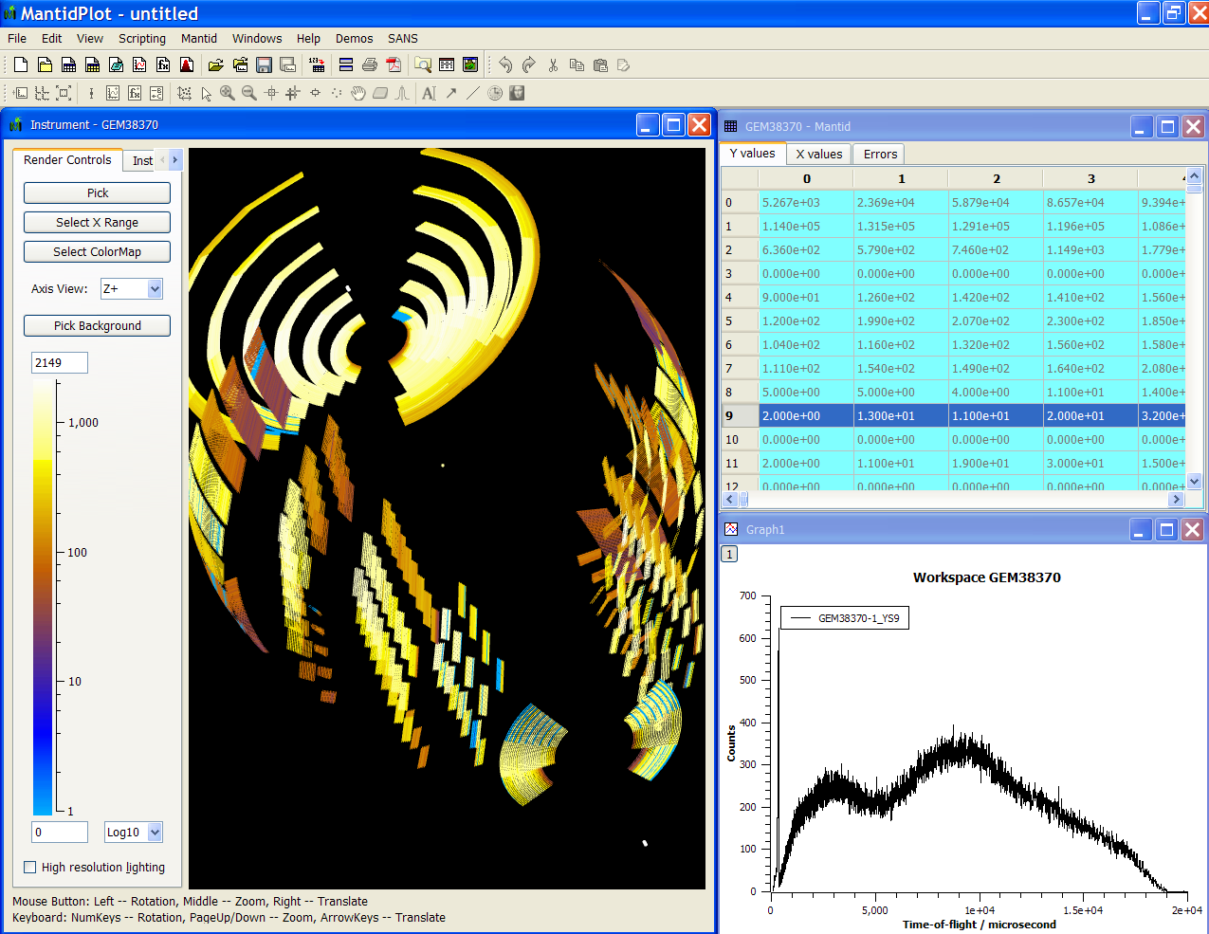
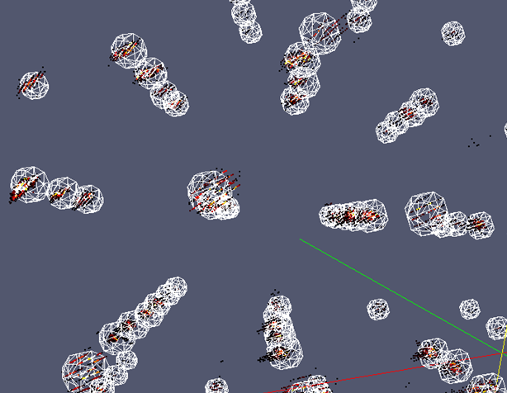
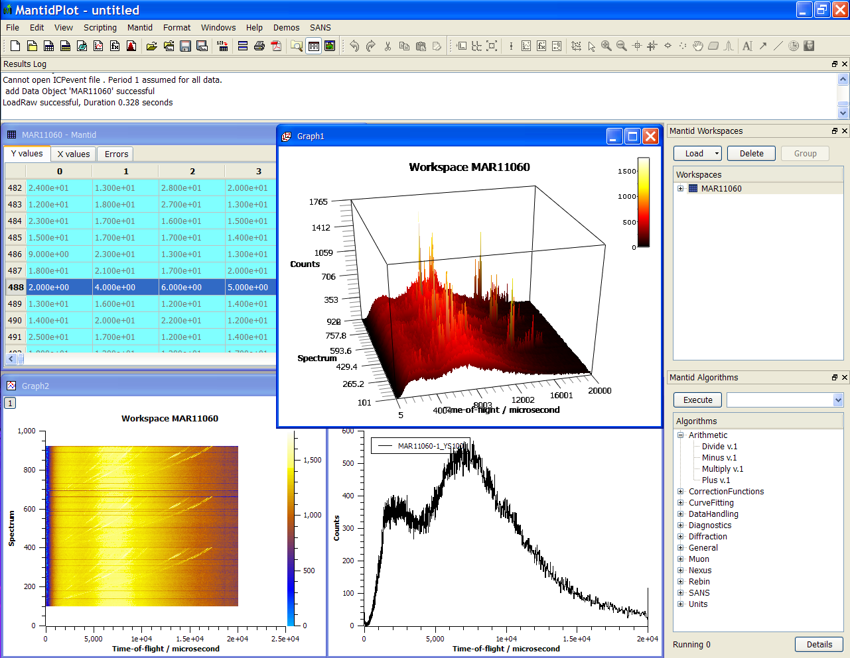
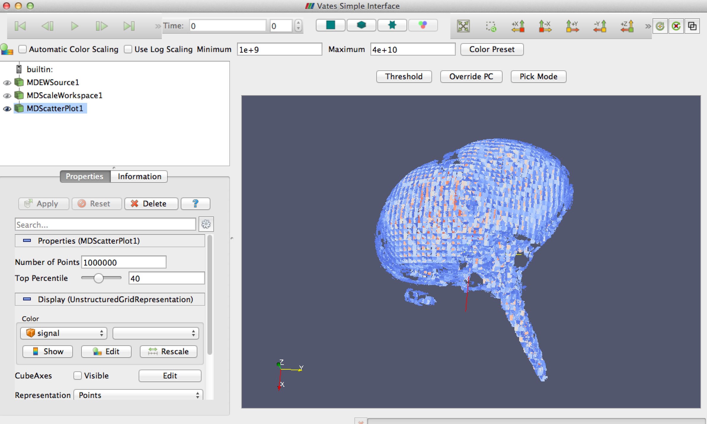
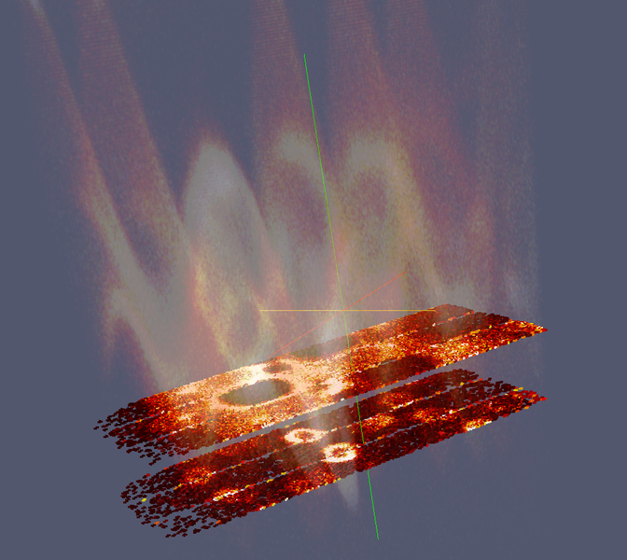
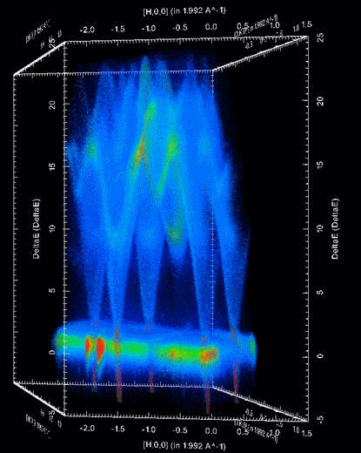

Document Control
This document is under document control. All members of the distribution list will receive updated copies whenever alterations are made. All other copies are uncontrolled.

Contributors
Name | Role | Company
Nicholas Draper | Author | Tessella

Document Approval
Name | Role | Company

Distribution
Name | Role | Company
Project Management Board Members | Recipient | Mantid Partnership
Mantid Project Repository | Filing | Mantid Partnership

Revision History
Author | Issue | Date | Description
Nicholas Draper | V1.R1.M0 | 29/05/2019 | 1st version written

References
Document | Ref | Date | Details and Version
Project Specification | [PS] |  | https://github.com/mantidproject/documents/blob/master/Project%20Management/ProjectSpecification.doc?raw=true
Stakeholder Plan | [SP] |  | https://github.com/mantidproject/documents/blob/master/Project%20Management/StakeholderPlan.doc?raw=true
Risk Register | [RR] |  | https://github.com/mantidproject/documents/blob/master/Project%20Management/RiskRegister.xls

Table of Contents
1 Introduction 3
2 Project Documentation 4
3 Project Status 4
4 User/Developer meeting 5
5 Total Diffraction 5
6 Mantid Project Managers Team 6
7 Usage of Mantid in various Environments 7
8 Future Release Dates 9
9 Appendix A: Metrics 10
10 Appendix B: Users Workshop Questionnaire Results 11

Introduction

Purpose of this Document
This report details the current state of the Mantid project. The project management board will use this report as an item for discussion at the meeting.

Scope of this Document
The scope of this document is limited to the Mantid project, both for progress up to the meeting of the Project management board, and plans for the future.

Project Documentation
The project documentation is available through the links below. The documents have not been changed since the last PMB meeting.

Stakeholder Plan:
https://github.com/mantidproject/documents/blob/master/Project-Management/Stakeholder%20Map.doc?raw=true
Reviewed, Updated.

Risk Register:
https://github.com/mantidproject/documents/raw/master/Project-Management/RiskRegister.xls
Reviewed, Updated.

Project Status

Development Progress
Release 4.0 was release on time on the 25th of March.

The next release 4.1 is planned for release on the 22nd of July, with the following release plan:
- Code Freeze: 22nd June
- Beta Test: 3-16th of June
The ISIS team has been significantly impacted by attrition earlier in the year increased effort in recruitment and selection has had an impact on the availability of certain senior team members.
We have successfully recruited a junior software scientist that will pick up the total scattering work from Elliot, and a replacement for the testing, user support and documentation role who will be starting in September.
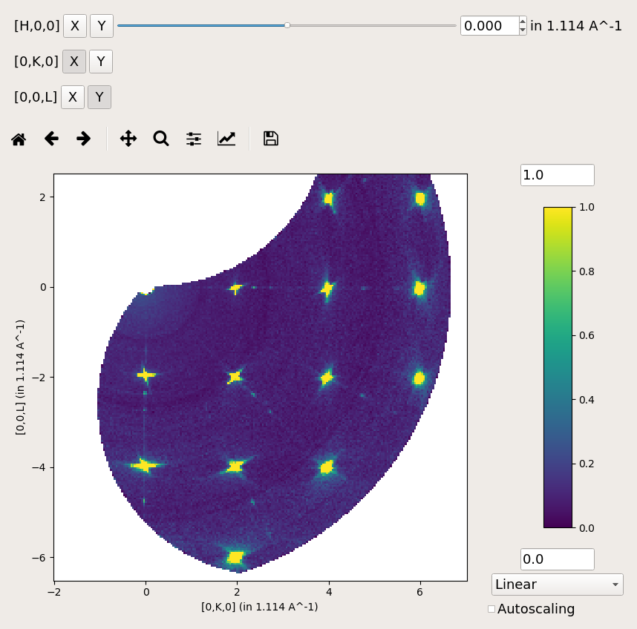
Given the number of changes already in place in the team and the anticipated upcoming people to join, we anticipate development velocity to be impacted while new staff are inducted into the team.

The project metrics in Appendix A.

Mantid Workbench
Since the release of Mantid 4.0 with the first implementation of the workbench included we have been making significant progress in the following areas:
- A First release of the rebuilt sliceviewer has been added
  - Supporting: Matrix and MD workspace types, multiple dimension slicing, colour map scaling, Zooming and panning.
  - Not supporting yet: Spectrumviewer like axes aligned plots, non-orthogonal axes, peaks overlays or lists, extraction of lines and lineviewer plots, ROI selection tools, logarithmic colour bar scaling, responsive colorfill plots with 10-100K spectra
- Porting remaining Interfaces:
  - The ISIS reflectometry interface is almost complete
  - The first ISIS indirect interface is complete, and we plan on getting the data reduction and analysis interfaces done for the release, allowing 90% of use cases.
- We have fixed many of the issues reported at the user meeting and from initial users after the release.
The full list of completed issues for the workbench in release 4.1 is available here.

User/Developer meeting

Feedback Questionnaire
We sent a feedback questionnaire to all attendees, the results from the 11 responses are summarised in Appendix B: Users Workshop Questionnaire Results

The Future of the VSI?
At the end of the user meeting during the feedback from the various groups a clear message was given from the Diffraction breakout group that the VSI as a tool did not meet their needs and was not useful to them. It does work as a visualization tool, but was not useful for extracting information such as peak positions and therefore was not useful to them. During discussions the Direct Inelastic breakout agreed and stated that they do not use or plan to use that tool as well.
This of course raises the questions:
- Should we assign the effort required to port the VSI to the workbench?
- Should we continue to support the VSI in Mantidplot?
I was concerned that we might not have had wide enough representation at the user workshop from all groups, so I posted a poll on the Mantid forum and advertised it on the Mantid home page. Asking if people actually used the VSI tool. The poll has been since the 25th of April. While it has only 5 responses so far I suspect that much of that is because most people don’t even know of the VSI.

Poll Results
Yes, I use the VSI | No, I don’t
Christina Hoffman | David Voneshen
 | Duc Le
 | Tatiana Guidi
 | Helen Walker

This can be simply summarised as no one from ISIS direct inelastic uses the tool, and one diffraction scientist from ORNL does. I suggest that Pete talks to Christina to find out how she uses it and consider any alternatives.

Total Diffraction
There have been significant changes in the team who were developing support for total scattering at both ISIS and ORNL that have significantly impacted progress in this area. At ORNL Marshall McDonnell has moved job to a different group, and at ISIS Elliot Oram has moved to lead the development of the Auto reduction project at ISIS.
As far as I understand Pete has taken ownership of total scattering development at ORNL, and at ISIS we are training up Harriet Brown, a Junior software scientist, with the view to them supporting this area in a couple of months.

Total scattering workshop / code camp
I propose that we hold a joint week long total scattering workshop / code camp to reinvigorate this area of work after the summer.
From ISIS we could suggest the following people:
- Nick Draper
- Helen Playford (Instrument scientist)
- Elliot Oram (previous developer)
- Harriet Brown (new developer)
From ORNL:
- Peter Peterson
- Anyone else?
Any others?

Mantid Project Managers Team
At the previous PMB the proposal was discussed and it was agreed that the Terms of Reference would be updated following the suggestions from Pete, Owen and I documented in my previous report.
I had considered putting these changes into action ahead of the final agreed terms of reference, but at the last ISIS PMC it was agreed that I should await the agreed terms of reference before implementing any changes.
I’ve included the section from my previous report here unchanged for reference.

Notes from the previous report
Pete Peterson, Owen Arnold and I met to discuss the Project Management team. We did not have a representative from the ILL at the meeting as a candidate has not yet been proposed.
We discussed how we might make this work in a practical context and the areas of responsibility we suggest we add or change in addition to the ToR discussed at the previous meeting.
Given the need for discussion and alignment across four facilities it is important that the local project managers have a clear understanding of the resources available to them, their flexibility and the authority to make decisions in the meeting.

Core team interaction with the PMT
We suggest that core team proposals be initially discussed by the PMT before being presented to the PMB.
Furthermore we suggest that the PMT be given delegated authority to authorise investigations and developments involving less up to 3 man months per facility. These would be reported at the next PMB, but could be started under that delegated authority.

TSC interaction with the PMT
The TSC and PMT need to work closely to direct the development of the project. We propose that one of the members of the PMT (not the current chair) be the chair of the TSC to ensure effective communication between the groups. All members of the PMT would be invited as optional observers to the TSC meetings, in order to better contribute into maintenance task planning etc.

Usage of Mantid in various Environments
We currently fully support the following environments:
- RHEL 7 64bit
- Windows 7/8/10 64 bit
- Ubuntu 16.04 64 bit
- Ubuntu 18.04 64 bit
- OS X 10.10+
The next release 4.1 was agreed at the last PMB to be the last one to support windows 7 or 8. Following the release the development team will upgrade any remaining windows 7 or 8 development PC’s and build servers to windows 10.
Questions:
- RHEL 8 has now been released, is there any timescales for the different facilities to adopt this?
- Ubuntu 16.04 64 bit is being maintained primarily for the ILL, what is the timeline for moving to 18.04?
- What are the OS plans for the ESS?

Current Usage:
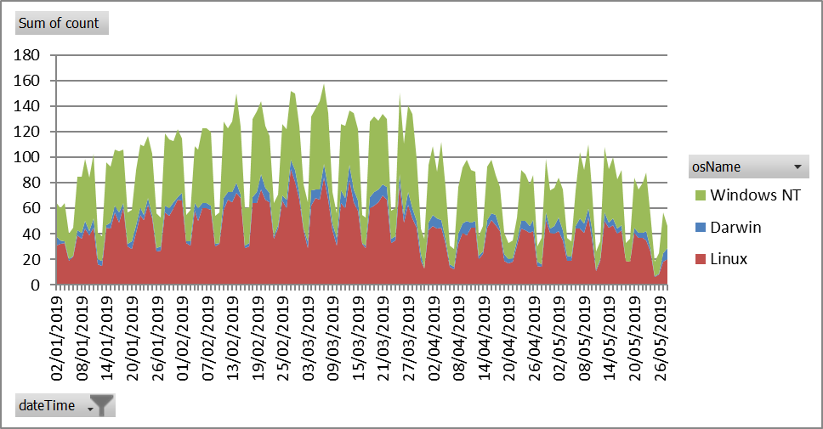

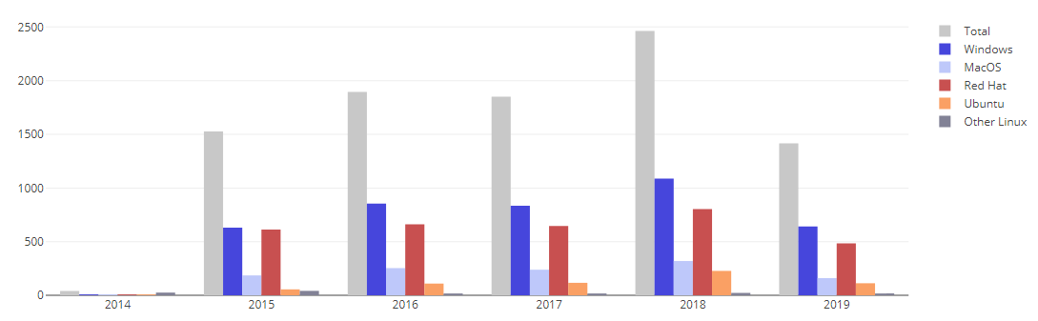
This graph shows the unique user count per year, the 2019 numbers are for the year so far.
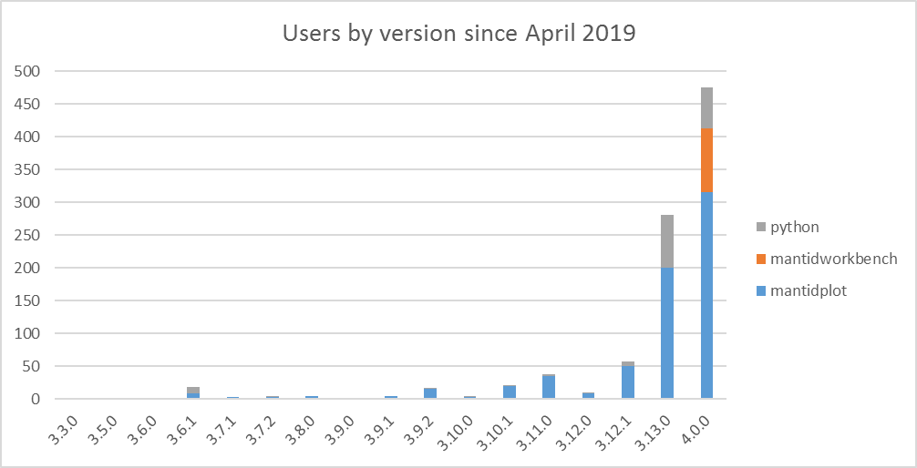

This is a view of the number of users that have used differenct versions of Mantid since April 2019, when Mantid 4.0 was released. This is a limited sample, but shows Version 4..0 has taken over from 3.13.0 in most areas as the primary version used.
We have a significant tail of old versions, this is not a problem per se as long of the users of those versions do not need active support. Given the approach of visiting scientists leaving with a locally installed version then this is to be expected as they are unlikely to upgrade from the version that works for them.

Error Reporting
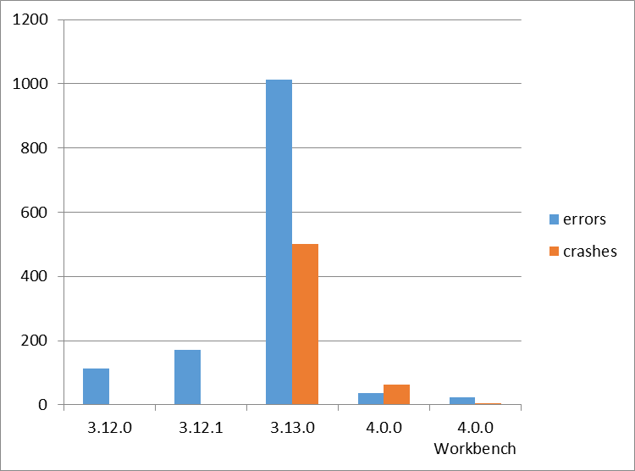
This graph shows both the raw numbers or errors and crashes sent through error reporting for each version. Our experince and the feedback we are getting from our users is that the large increase in 3.13 is due to more issue being reported, rather than Mantid being less stable. As version 4.0.0 has only been released for a few months we would expect the counts for that to continue to increase For the sake of this graph they are defined as:
- Errors – Problems that caused the ast chance error dialog within Mantidplot to appear.
- Crashes – Problems where Mantidplot exited impropoerly, this can include situations where it is terminated because it has hung.
Crash reporting was only introduced in release 3.13.0, so these occaisions went unreported in previous versions

Future Release Dates
Planned dates:
- v4.2 18th November 2019

Appendix A: Metrics

Project Metrics
The code metrics are independently generated and displayed here
http://www.openhub.net/p/Mantid/analyses/latest/languages_summary

Total Lines : | 2,513,619 |  | Code Lines : | 1,801,311 |  | Percent Code Lines : | 71.7%
Number of Languages : | 17 |  | Total Comment Lines : | 394,510 |  | Percent Comment Lines : | 15.7%
 |  |  | Total Blank Lines : | 317,798 |  | Percent Blank Lines : | 12.6%

Code, Comments and Blank Lines
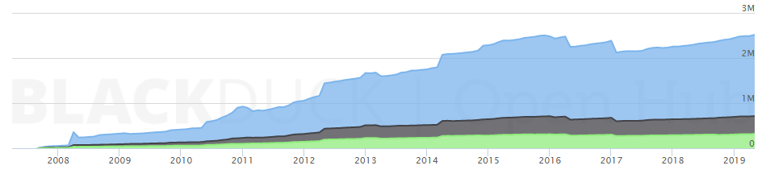
Code
Comments
Blanks

In a Nutshell, Mantid...
- has had 104,590 commits made by 168 contributors representing 1,801,311 lines of code
- is mostly written in C++ with an average number of source code comments
- has a well established, mature codebase maintained by a very large development team with stable Y-O-Y commits
- took an estimated 517 years of effort (COCOMO model) starting with its first commit in April, 2007

Appendix B: Users Workshop Questionnaire Results
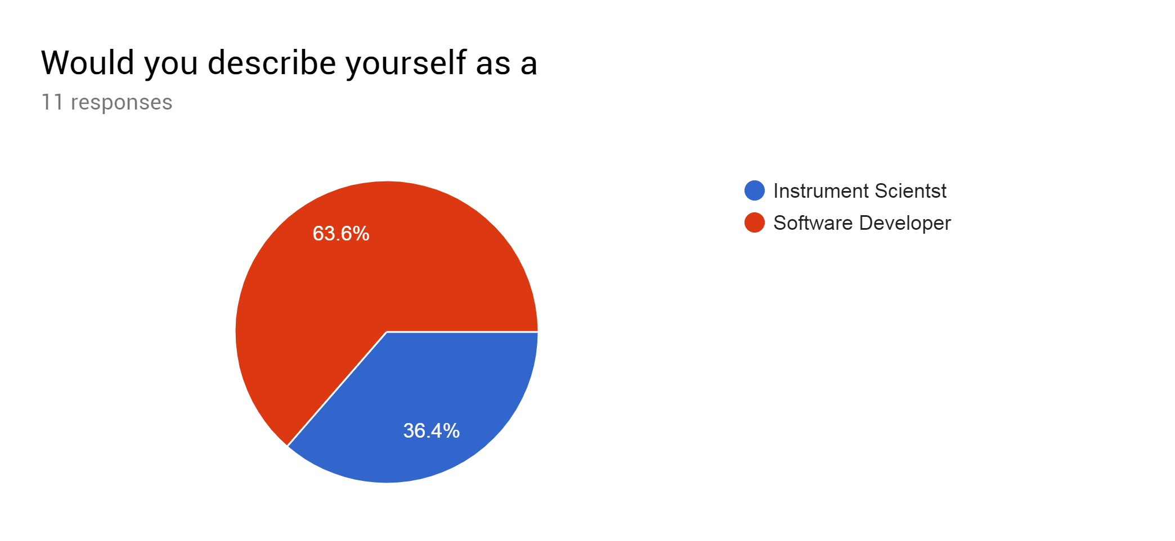
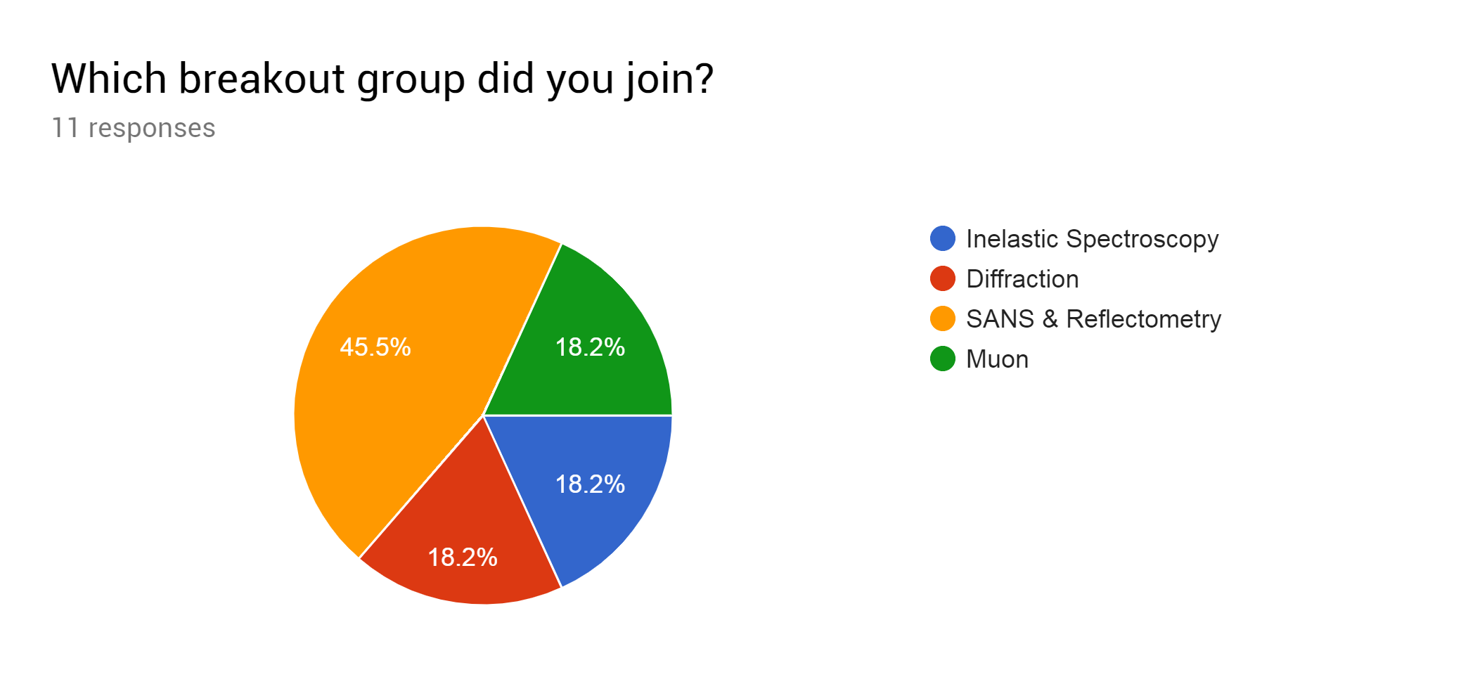
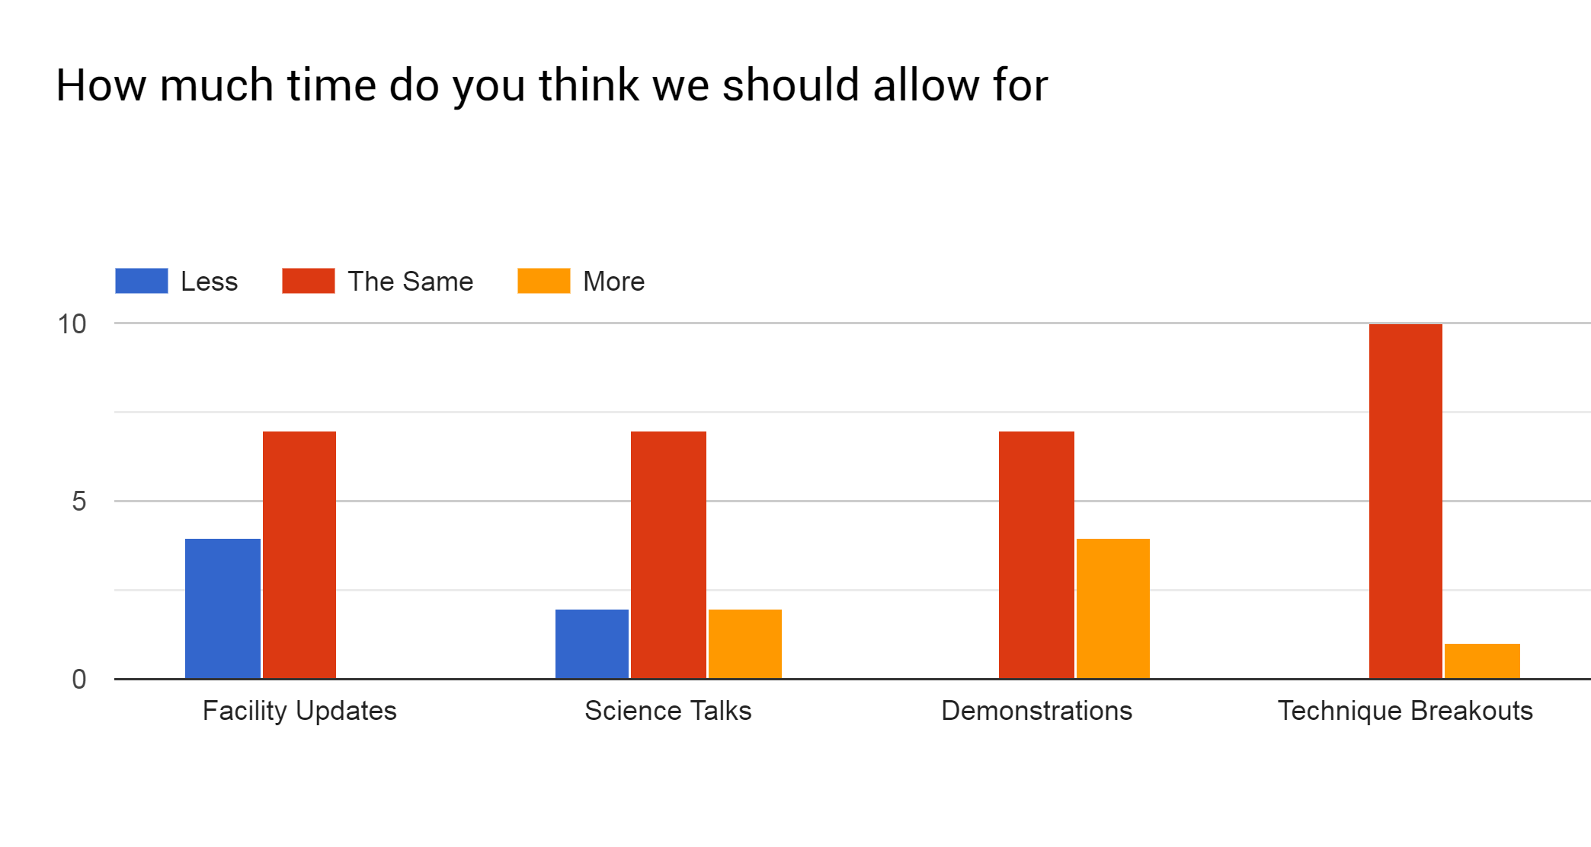
Do you have any suggestions to improve the breakout sessions?
3 responses

More focused questions
Begin the breakout session with a little status of Mantid usages (How much (time) used, which sub-parts for the technique are used more, which are not used much, is there something not used at all?)
Maybe identify & brief the breakout chairs/rapporteurs in advance so as to give them a chance to think about what the session needs to achieve rather than having to come to it cold.

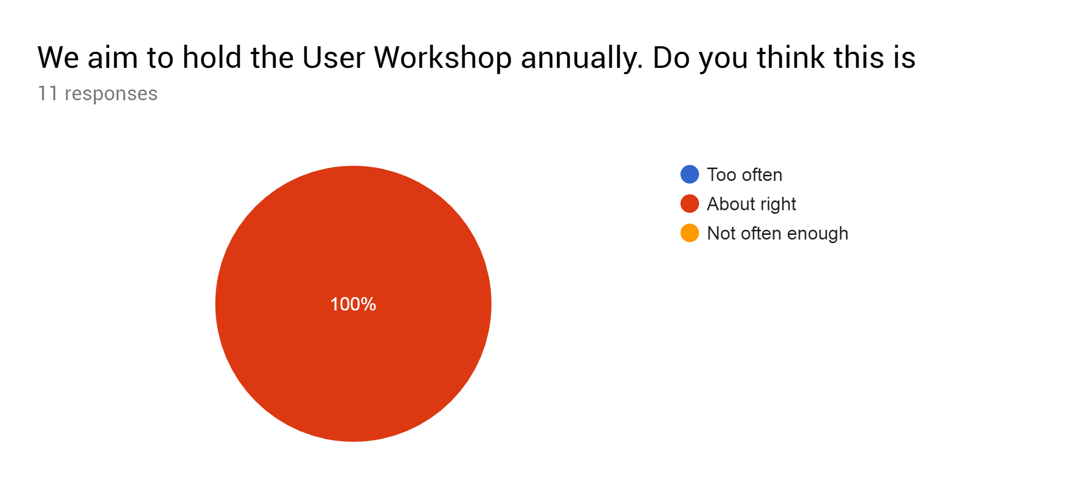
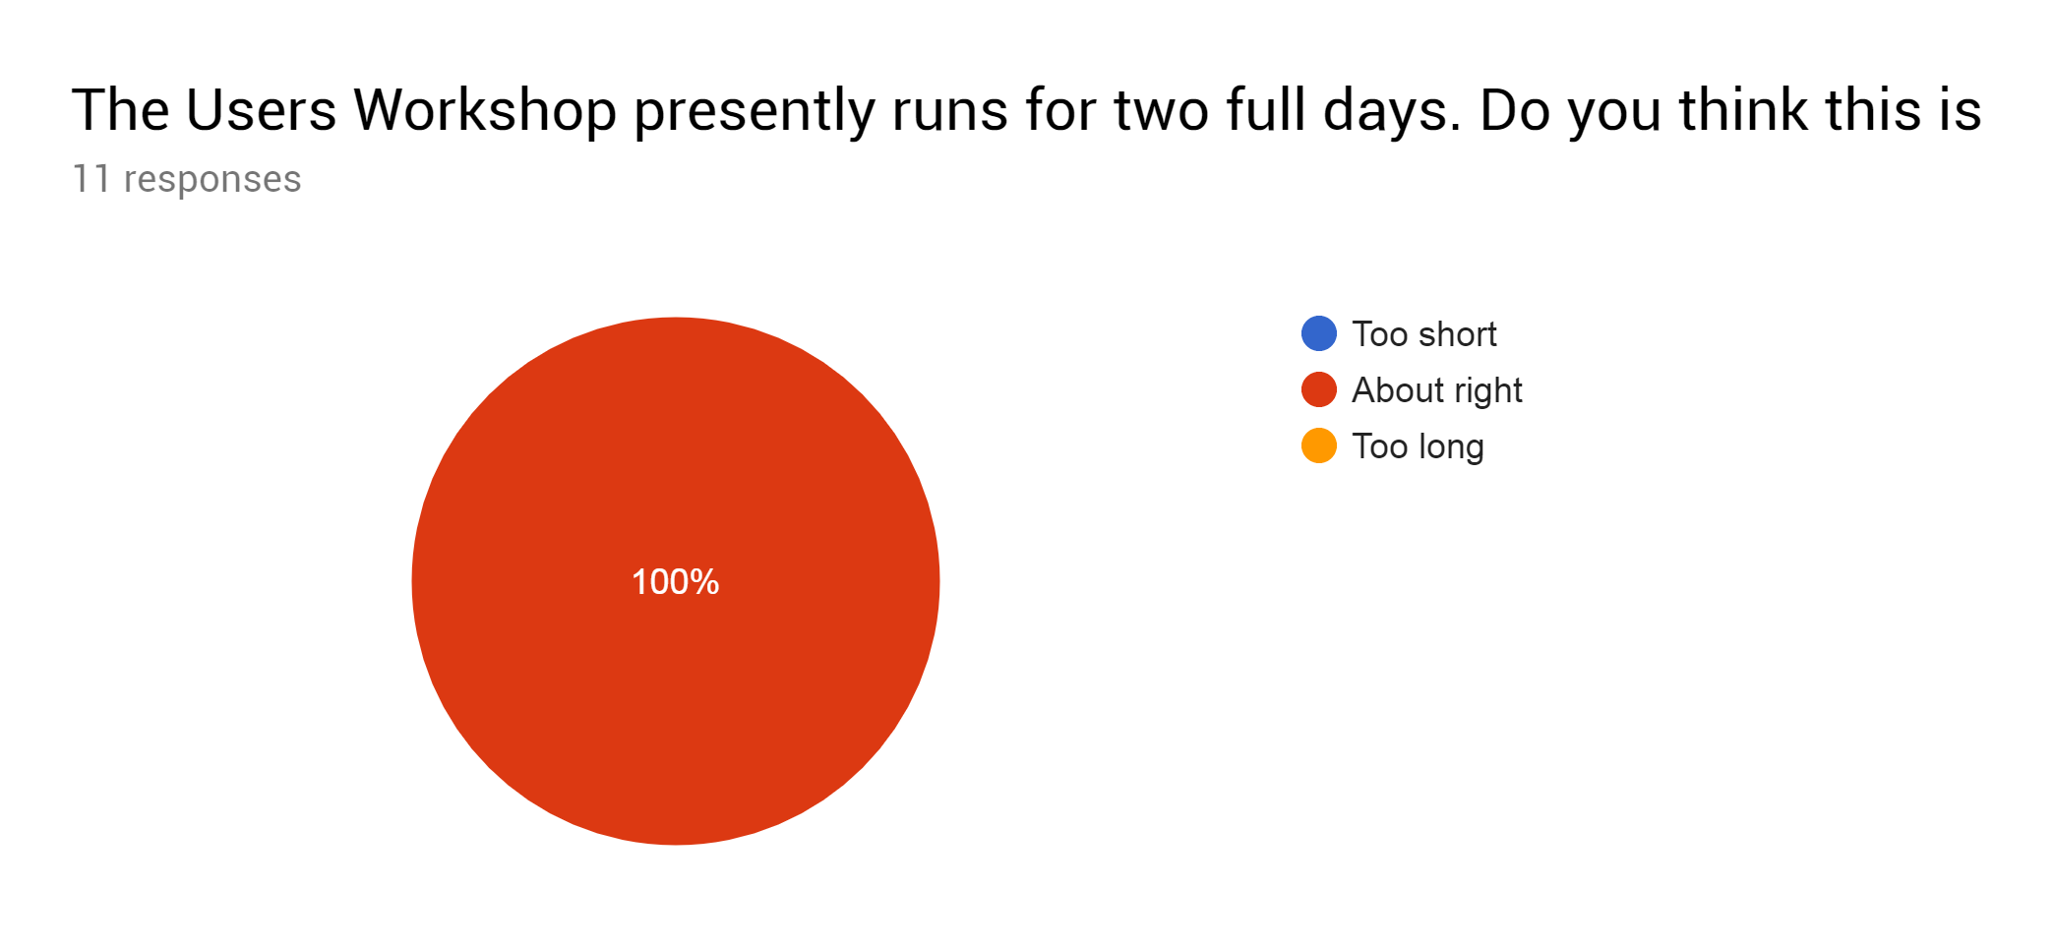

What did you like best about the Users workshop?
7 responses

Hearing what other 'groups' were doing. Seeing the overlap.
Technique breakouts are very useful.
Good opportunity to discover areas for cross facility collaboration
Science talks, discussions with expert scientists
Meeting developers and scientists from other institutes
Useful interactions between the differing techniques and the developers
Talking to other facilities

What do you think we could improve on?
6 responses

Cross group communications
Facility updates need more structure and should not be as in depth as some of them were.
I think, the workshop would benefit if more scientists would attend it
The facility updates should be shorter, maybe 5 minutes?
Interaction with users -> treating data online, treating data in different ways
Greater participation from a wider range of Facility scientists would undoubtedly help the technique breakouts.

Do you have any other suggestions for future workshops?
2 responses

Try and get more facility (and users) to attend. It was disappointing that very few ILL staff did not attend
Some way of encouraging more scientists attending would be useful I think, though not sure how

